XML Code:

<?xml version="1.0" encoding="utf-8"?>

<androidx.constraintlayout.widget.ConstraintLayout xmlns:android="http://schemas.android.com/apk/res/android"

xmlns:app="http://schemas.android.com/apk/res-auto"

xmlns:tools="http://schemas.android.com/tools"

android:layout_width="match_parent"

android:layout_height="match_parent"

tools:context=".MainActivity">

<Spinner

android:id="@+id/spinner"

android:layout_width="match_parent"

android:layout_height="wrap_content"

app:layout_constraintBottom_toBottomOf="parent"

app:layout_constraintEnd_toEndOf="parent"

app:layout_constraintHorizontal_bias="0.0"

app:layout_constraintStart_toStartOf="parent"

app:layout_constraintTop_toTopOf="parent"

app:layout_constraintVertical_bias="0.352" />

</androidx.constraintlayout.widget.ConstraintLayout>

Java Code:

package com.example.spinner;

import androidx.appcompat.app.AppCompatActivity;

import android.os.Bundle;

import android.view.View;

import android.widget.AdapterView;

import android.widget.ArrayAdapter;

import android.widget.Spinner;

import android.widget.Toast;

public class MainActivity extends AppCompatActivity implements

AdapterView.OnItemSelectedListener{

String country[]={"India","USA","UK","UAE","Others"};

Spinner sp;

@Override

protected void onCreate(Bundle savedInstanceState) {

super.onCreate(savedInstanceState);

setContentView(R.layout.activity_main);

sp = findViewById(R.id.spinner);

sp.setOnItemSelectedListener(this);

ArrayAdapter ad = new ArrayAdapter(this, android.R.layout.simple_spinner_dropdown_item, country);

ad.setDropDownViewResource(android.R.layout.simple_spinner_dropdown_item);

sp.setAdapter(ad);

}

@Override

public void onItemSelected(AdapterView<?> parent, View view, int position, long id) {

Toast.makeText(getApplicationContext(),"You selected "+country[position], Toast.LENGTH_SHORT).show();

}

@Override

public void onNothingSelected(AdapterView<?> parent) {

}

}

Output

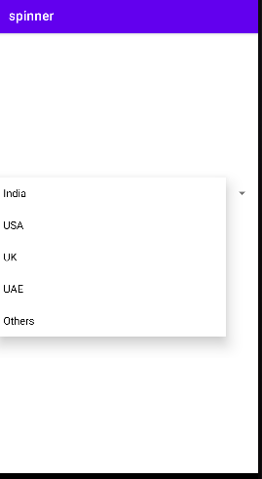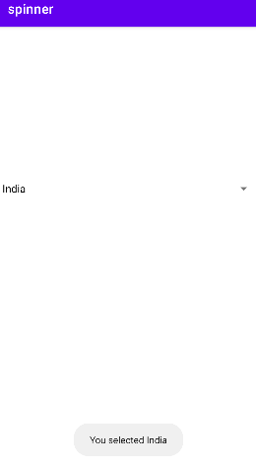

Fragments

XML Code:

<?xml version="1.0" encoding="utf-8"?>

<LinearLayout xmlns:android="http://schemas.android.com/apk/res/android"

xmlns:app="http://schemas.android.com/apk/res-auto"

xmlns:tools="http://schemas.android.com/tools"

android:layout_width="match_parent"

android:layout_height="match_parent"

android:orientation="vertical"

tools:context=".MainActivity">

<RelativeLayout

android:layout_width="match_parent"

android:layout_height="0dp"

android:layout_weight="1">

<Button

android:id="@+id/b1"

android:layout_width="160dp"

android:layout_height="50dp"

android:layout_alignParentBottom="true"

android:layout_marginStart="30dp"

android:layout_marginBottom="30dp"

android:backgroundTint="#2196F3"

android:text="Fragment1" />

<Button

android:id="@+id/b2"

android:layout_width="160dp"

android:layout_height="50dp"

android:layout_alignParentRight="true"

android:layout_alignParentBottom="true"

android:layout_marginStart="30dp"

android:layout_marginBottom="30dp"

android:backgroundTint="#FFC107"

android:text="Fragment2" />

</RelativeLayout>

<FrameLayout

android:id="@+id/frameLayout"

android:layout_width="match_parent"

android:layout_height="0dp"

android:layout_weight="4"

android:background="@color/purple_200"/>

</LinearLayout>

Firstfragment.xml

*<?*xml version="1.0" encoding="utf-8"*?>*

<RelativeLayout xmlns:android="http://schemas.android.com/apk/res/android"

xmlns:tools="http://schemas.android.com/tools"

android:layout_width="match_parent"

android:layout_height="match_parent"

android:background="@color/teal_200"

tools:context=".Fragment1">

<TextView

android:layout_width="wrap_content"

android:layout_height="wrap_content"

android:layout_centerInParent="true"

android:background="#FFEB3B"

android:text="Fragment1"

android:textSize="30dp" />

</RelativeLayout>

Secondfragment.xml

*<?*xml version="1.0" encoding="utf-8"*?>*

<RelativeLayout xmlns:android="http://schemas.android.com/apk/res/android"

xmlns:tools="http://schemas.android.com/tools"

android:layout_width="match_parent"

android:layout_height="match_parent"

android:background="#FFEB3B"

tools:context=".Fragment2">

<TextView

android:layout_width="wrap_content"

android:layout_height="wrap_content"

android:layout_centerInParent="true"

android:background="#FAA3C1"

android:text="Fragment2"

android:textSize="30dp" />

</RelativeLayout>

Java Code

Mainactivity.java

package com.example.fragment;

import androidx.appcompat.app.AppCompatActivity;

import androidx.fragment.app.Fragment;

import androidx.fragment.app.FragmentManager;

import androidx.fragment.app.FragmentTransaction;

import android.os.Bundle;

import android.view.View;

import android.widget.Button;

public class MainActivity extends AppCompatActivity {

Button b1,b2;

@Override

protected void onCreate(Bundle savedInstanceState) {

super.onCreate(savedInstanceState);

setContentView(R.layout.*activity_main*);

b1=findViewById(R.id.*b1*);

b2=findViewById(R.id.*b2*);

b1.setOnClickListener(new View.OnClickListener() {

@Override

public void onClick(View v) {

loadfrag(new Fragment1());

}

});

b2.setOnClickListener(new View.OnClickListener() {

@Override

public void onClick(View v) {

loadfrag(new Fragment2());

}

});

}

private void loadfrag(Fragment fragment) {

FragmentManager fragmentManager=getSupportFragmentManager();

FragmentTransaction fragmentTransaction=fragmentManager.beginTransaction();

fragmentTransaction.replace(R.id.*frameLayout*,fragment);

fragmentTransaction.commit();

}

}

Fragment1.java

package com.example.fragment;

import android.os.Bundle;

import androidx.fragment.app.Fragment;

import android.view.LayoutInflater;

import android.view.View;

import android.view.ViewGroup;

public class Fragment1 extends Fragment {

@Override

public View onCreateView(LayoutInflater inflater, ViewGroup container,

Bundle savedInstanceState) {

return inflater.inflate(R.layout.*fragment_1*, container, false);

}

}

Fragment2.java

package com.example.fragment;

import android.os.Bundle;

import androidx.fragment.app.Fragment;

import android.view.LayoutInflater;

import android.view.View;

import android.view.ViewGroup;

public class Fragment2 extends Fragment {

@Override

public View onCreateView(LayoutInflater inflater, ViewGroup container,

Bundle savedInstanceState) {

return inflater.inflate(R.layout.*fragment_2*, container, false);

}

}

OUTPUT

